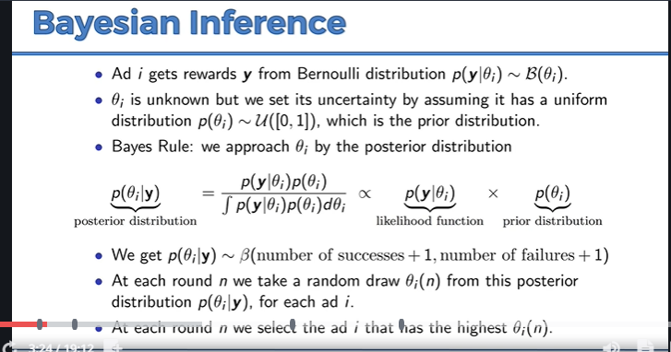

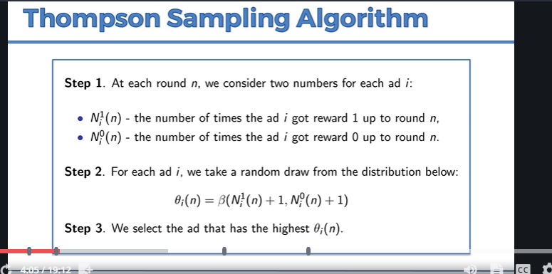

We are not trying to guess the distribution of machines. Instead, we are constructing distribution where we think the actual expected value might lie. Eg, we are creating the possible ways that the machine could have been created.

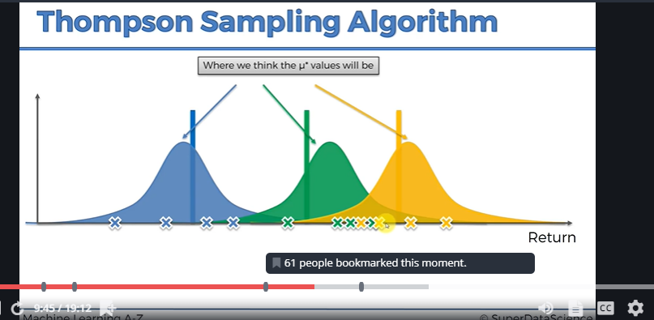

Basically, the algorithm created an ‘imaginary’ distribution curve based on just a few data points and assume the actual distribution value is within that bound.

Thompson sampling: probabilistic algorithm

UCB: deterministic algorithm

So in each round, the virtual map will generates several “expected” values (randomly), and the point with highest value will be picked and compared with the “actual” value from the specific machine that the curve represents. Then, the point in the virtual world will get adjusted to get closer to the “expected actual value” based on the difference between “expected” values and “expected actual” values. (Also, the curve will become slimmer and the result will be more converged.)

